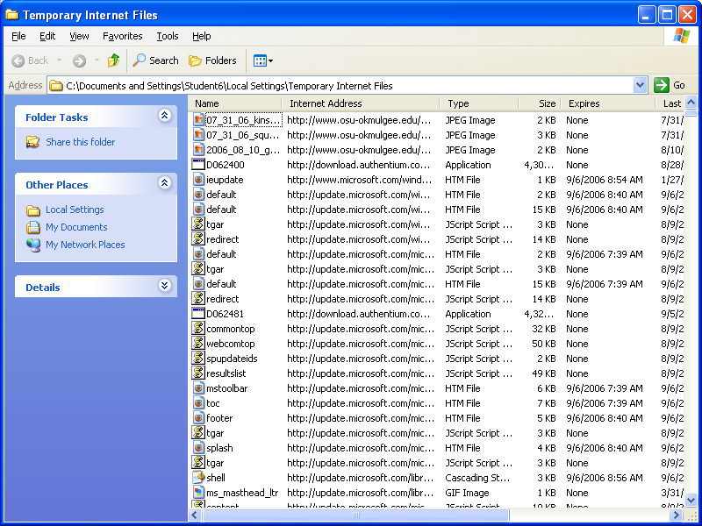
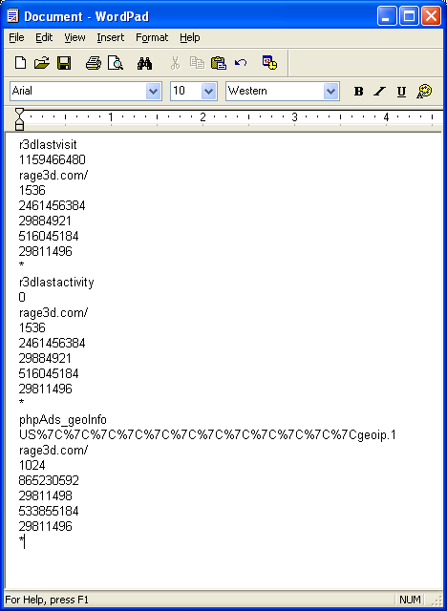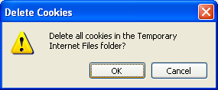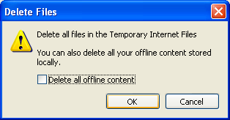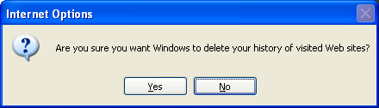
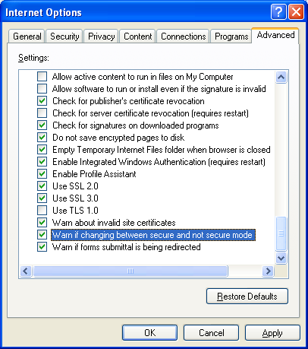

Summary
This setup is good for a workstation where a lot of people will get on and off. It automatically nukes history and temporary files. It also is secure by not saving encrypted pages to disk. I don’t use Internet Explorer often, so I usually go the extra mile – I put the Internet zone in “High” security. This seems to me as the safest, especially since I don’t use the browser except when it’s embedded in some other application. This project is essentially part of my standard procedure, so I can’t really comment on it. I’ve done this before many times, and it’s not new for me.

